Challenge 1: Mohammed Mujahed.
- Launch one aws ec2 and install jenkins.
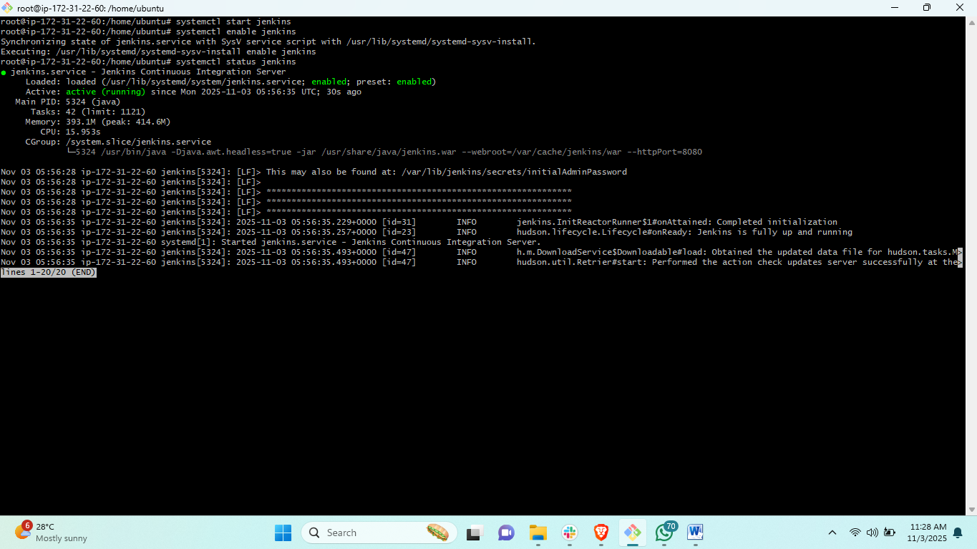
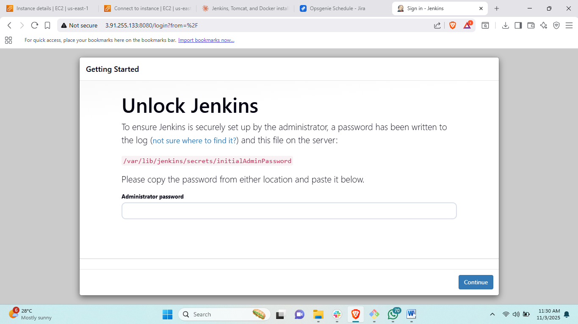
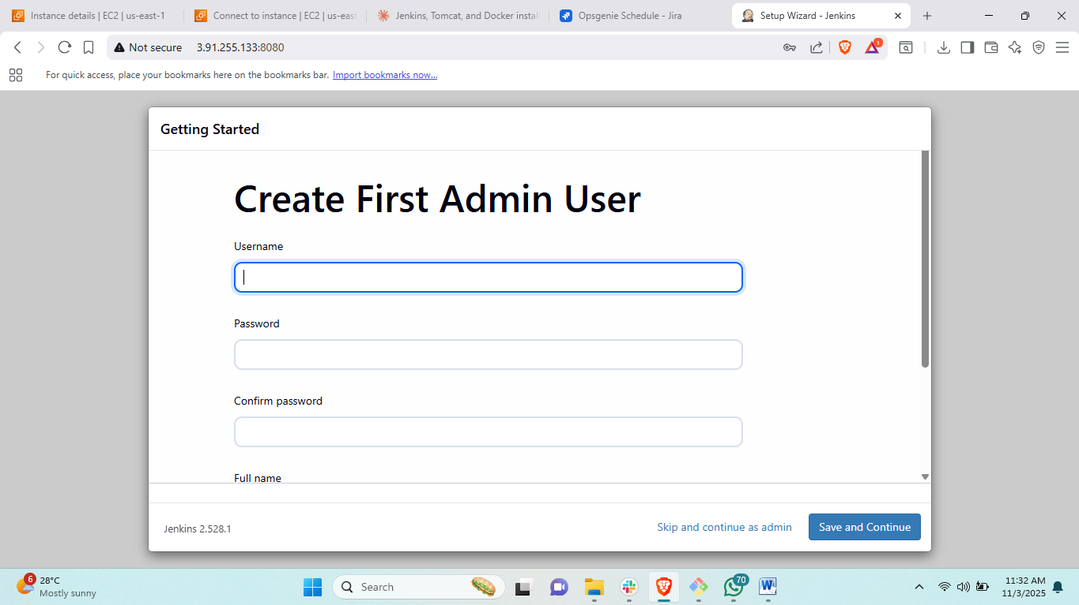
- Setup Apache Tomcat on Ubuntu Virtual Machine.
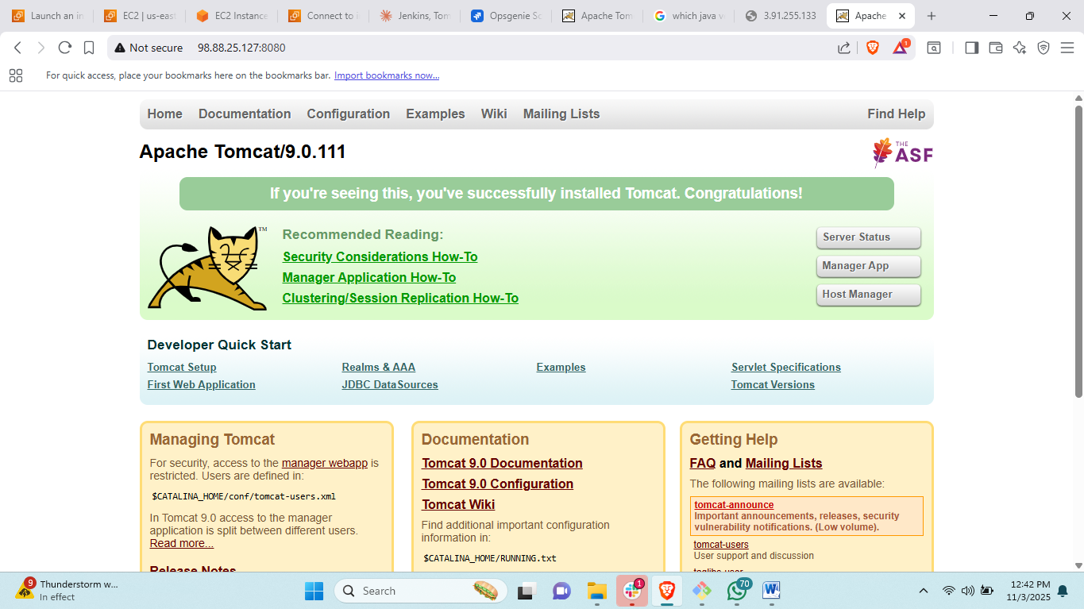
- Setup Docker Desktop on your local windows.
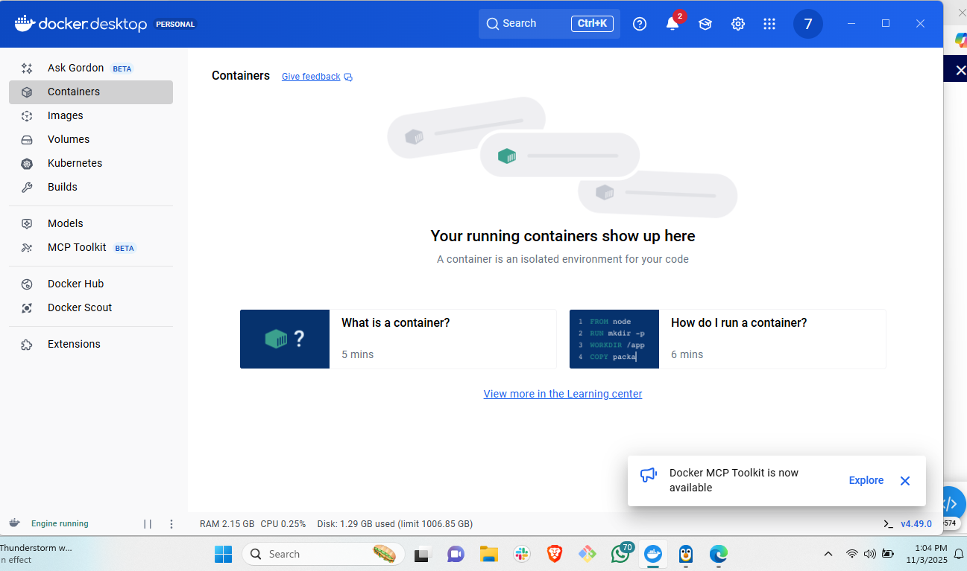

Log off only after completing all pending tasks and challenges till date.

